Interpretable Machine-Learning Analysis of Composition-Process-Property Relationships in High-Strength Steel Weld Metals
Ebrahim Harati
Department of Engineering Science, University West, Trollhattan, Sweden

Abstract
High-strength steel weld metals are controlled by coupled effects of filler chemistry, base-metal chemistry, dilution, cooling rate and bead sequence. This work re-analyses an existing experimental dataset on Weldox 700 and Weldox 1100 welds produced using MMA, GMAW/MAG, Rapid Arc, laser-hybrid welding and SAW. The original studies showed that dilution varied from approximately 3% to 73%, weld metals were mainly martensitic/bainitic, Weldox 700 welds were overmatching, and weld metals in Weldox 1100 reached strengths above 1000 MPa [1-3]. The present contribution is an interpretable data-driven analysis of these results rather than a new experimental campaign. A cleaned dataset of 30 weld conditions was developed and analysed using correlation analysis, carbon-equivalent comparison, regression and small-data machine learning. Compact descriptors included Pcm, CE_{IIW}, CEn, CET, measured t8/5, bead number, Ni-based dilution, base-metal grade and single-pass/multipass condition. Pcm was the best compact carbon-equivalent descriptor for strength. A compact model using Pcm, t8/5, bead count, dilution, single-pass condition and base-metal grade predicted Rp0.2 and Rm with leave-one-out cross-validated R2 values of approximately 0.68 and 0.66, respectively. Full-chemistry models improved prediction, with ridge regression giving R2 = 0.88 for Rp0.2 and partial least squares regression giving R2 = 0.85 for Rm. Charpy toughness was less predictable, indicating that toughness requires microstructural and cleanliness descriptors beyond bulk chemistry and process variables.
Keywords: high-strength steel; weld metal; dilution; Pcm; cooling time; t8/5; Charpy toughness; hardness; machine learning; weldability.

1. Introduction
The demand for high-strength steels with yield strengths of 700 MPa and above is continuously increasing. These steels are increasingly used in structural applications where weight reduction, productivity and load-carrying capacity are important, such as cranes, transport structures, offshore components, pipelines and heavy engineering structures. In such applications, the practical and competitive use of high-strength steels depends not only on the properties of the base material, but also on the availability of reliable, flexible and productive welding procedures. Steels with yield strengths up to at least 900 MPa have been successfully welded for many years, often using matching or near-matching weld metals. However, the growing use of even higher strength steels has increased the demand for welds with higher matching strength, adequate toughness and acceptable weldability. Consequently, there is a need for improved high-strength welding consumables and a better understanding of how welding method, heat input, interpass temperature, cooling time and bead sequence affect weld-metal properties [1,5].
Modern high-strength steels are commonly lean in alloying content and obtain their strength through thermomechanical processing, controlled rolling, quenching and tempering. In contrast, welding consumables designed to produce matching or near-matching weld-metal strength are usually more highly alloyed, particularly with elements such as Ni, Mn, Cr and Mo [1,5]. This difference between base-metal and filler-metal chemistry makes dilution a critical variable. The final weld-metal composition is not simply the nominal consumable composition, but the result of mixing between melted base metal and added filler metal, together with possible element losses during welding [1,11]. Therefore, dilution directly influences weld-metal hardenability, microstructure, strength and toughness.
Several mechanisms contribute to the strength and toughness of weld metals. Chemical composition, carbon equivalent, grain morphology, grain size, microstructure and weld-metal cleanliness are among the most important factors. Low levels of impurities and controlled oxygen content are also important for achieving acceptable impact toughness. However, these metallurgical features are not independent. They are strongly influenced by welding-related variables such as dilution, number of passes, cooling time from 800 °C to 500 °C, welding process and thermal history. For example, dilution changes the final weld-metal chemistry; welding process affects dilution and heat flow; cooling time controls transformation behaviour; and number of beads influences reheating, tempering and local property gradients. The final mechanical response is therefore controlled by coupled composition–process–microstructure–property relationships rather than by one isolated parameter.
A purely experimental comparison between different welding processes may therefore be insufficient to separate the individual effects of chemistry, dilution, cooling time and bead sequence. For example, laser-hybrid welding may combine high dilution with a single-pass thermal history, whereas MMA welding may provide low dilution but significant multipass reheating. Similarly, a weld metal with high Pcm may not necessarily show the highest toughness if the resulting microstructure contains coarse bainitic or martensitic constituents. These interactions make high-strength steel weld metals suitable for interpretable data-driven analysis, where statistical and machine-learning methods can be used to identify trends, rank variables and evaluate whether compact descriptors are sufficient for property prediction.
Previous studies on high-strength weld metals have shown that tensile strength can often be rationalised using the carbon-equivalent parameter Pcm [5]. Svensson reviewed several high-strength weld-metal datasets and showed an approximately linear increase in tensile strength with Pcm, although yield strength generally showed larger scatter [5]. The same review also showed that toughness cannot be explained by Pcm alone, because different Mn–Ni alloying concepts can produce different microstructures, including acicular ferrite, bainite, martensite and coalesced bainite [5–8]. This is important because strong microstructural constituents such as martensite and coarse bainite may increase strength while reducing toughness. In general, increasing weld-metal strength is often accompanied by a reduction in toughness, and this trade-off becomes more pronounced at very high strength levels.
The experimental basis of the present paper comes from a previously published article on Weldox 700 and Weldox 1100 steels welded using MMA, GMAW/MAG, Rapid Arc, laser-hybrid welding and submerged arc welding [1–3]. The article showed that high-quality welds could be produced using several welding methods. Dilution varied strongly, from very low values in multipass MMA welds to very high values in laser-hybrid welds. The weld metals were mainly martensitic/bainitic, and the fraction of martensite increased with increasing alloying content and more rapid cooling [1,2]. The results also showed that low dilution, rapid cooling and single-pass welding contributed to higher strength, whereas impact toughness generally decreased with increasing strength and dilution [1,2].
Machine learning has increasingly been used in welding research, particularly for weld-bead geometry prediction, weld-quality monitoring, defect detection and online process control. However, fewer studies have focused on small but metallurgically rich datasets where destructive testing, weld-metal chemistry and process history are combined to understand mechanical properties. In such cases, black-box models are less suitable, and interpretable models are preferable because the results must remain consistent with welding metallurgy.
The aim of the present paper is to develop an interpretable data-driven analysis of high-strength steel weld-metal data using statistical methods and small-data machine learning. The study links weld-metal chemistry, dilution, cooling time, bead sequence and mechanical properties in order to identify the most influential variables controlling strength, toughness and weldability. The novelty lies in using interpretable modelling to transform experimental welding data into quantitative composition–process–property relationships that can support welding procedure development for high-strength steels.

2. Experimental procedure and dataset construction

2.1 Original welding programme
The experimental data were obtained from previous studies on 12 mm Weldox 700 and Weldox 1100 plates with yield strengths of approximately 777 MPa and 1193 MPa, respectively [1-3]. Welding was carried out using MMA, GMAW/MAG with solid wire, GMAW/MAG with metal-cored wire, Rapid Arc, laser-hybrid welding and SAW. The consumables included covered electrodes, solid wires, metal-cored wires and wire/flux combinations with nominal strength levels above 800 MPa [1].
The original welding programme used different groove geometries and bead numbers depending on process. MMA welds were multipass welds with up to 10 beads, conventional GMAW/MAG welds used several beads, SAW used 8 beads, while Rapid Arc and laser-hybrid welds were single-pass conditions [1,2]. Preheating of 50 C and 75 C was used for Weldox 700 and Weldox 1100, respectively [1].
Cooling time between 800 C and 500 C, t8/5, was measured using thermocouples. The measured values varied from approximately 5 s for MMA and laser-hybrid welds to approximately 10 s for SAW and 12 s for Rapid Arc [1,2]. The use of measured t8/5 is important because calculated cooling times can deviate from measured values. Sikstrom et al. showed that calculated cooling times may overestimate the measured values, especially at higher heat input, and that backing conditions and heat-flow assumptions can strongly influence the actual cooling behaviour [4].

2.2 Testing and chemical analysis
The original programme included weld metal tensile testing, transverse tensile testing, Charpy-V impact testing and hardness measurements [1-3]. Longitudinal tensile specimens were extracted from the weld metal centre. Transverse tensile specimens were used to evaluate overall joint performance and fracture location. Charpy-V specimens were notched in the weld metal centre and tested from -80 C to room temperature [1,2].
Hardness was measured using HV10 on weld cross-sections. The previous work reported typical hardness ranges of approximately 250-350 HV10 in Weldox 700 weld metals and 300-400 HV10 in Weldox 1100 weld metals. HAZ softening was also observed, especially in the higher-strength steel [1].
Chemical analysis was performed on weld metal, all-weld metal and base material. Most elements were analysed using optical emission spectroscopy, while C, S, O and N were analysed using combustion analysis [1]. Dilution was mainly calculated from Ni because Ni differed strongly between base metal and filler and is relatively less affected by oxidation and slag reactions than elements such as Si or Mn [1].
The choice of dilution method is important. Zhang et al. discussed limitations of traditional geometric and single-element dilution methods and showed that dilution calculated from chemical composition can vary strongly depending on which element is used [11]. This supports the approach used in the present dataset: dilution should be treated as an element-dependent chemistry variable, and Ni-based dilution should be interpreted as a practical indicator rather than as a universal dilution value.

2.3 Cleaned dataset
For the present analysis, the experimental data were reorganised into a cleaned master table. Each row represents one weld condition. Base material rows, all-weld metal rows, non-usable defect-only rows, zero-filled placeholders and incomplete plasma trials were separated from the modelling dataset. Repeated chemical analyses were harmonised by prioritising weld cross-section analyses when available. When equivalent repeated measurements existed, averaged values were used. Table 1 summarises the cleaned dataset used for the data-driven analysis.
Table 1. Summary of cleaned dataset and modelling subsets.
Dataset or target property | Usable records | Comment
Cleaned weld conditions | 30 | Main composition-process-property dataset
Rp0.2 / Rm modelling | 25 | Complete cases with strength and descriptors
Charpy -40 C modelling | 27 | Complete cases with impact toughness
Hardness descriptor modelling | 21 | Global hardness descriptors extracted from HV10 data

The main input variables were chemical composition, carbon equivalents, process variables and mechanical-property targets. Table 2 summarises the feature groups used in the modelling.
Table 2. Feature groups used in the interpretable ML analysis.
Feature group | Variables
Chemistry | C, Si, Mn, Cr, Ni, Mo, V, Nb, Cu, B, O, N
Carbon equivalents | CEIIW, Pcm, CEn, CET
Process descriptors | Welding method, base material, consumable type, t8/5, bead number, dilution, single-pass/multipass condition
Strength targets | Rp0.2, Rm, elongation
Toughness targets | Charpy-V impact toughness at different temperatures
Weldability descriptors | Transverse tensile fracture location, hardness descriptors, defect/weldability observations

3. Data analysis and machine-learning methods
Two types of models were used. The first was a compact engineering model using physically meaningful variables: {Pcm, t8/5, Nbeads, DilutionNi, SinglePass, Base1100}. This model was designed to be interpretable and suitable for welding procedure discussion.
The second model family used full chemistry plus process descriptors: {C, Si, Mn, Cr, Ni, Mo, V, Nb, Cu, B, O, N, Pcm, t8/5, Nbeads, Dilution, SinglePass, Base1100}.
The models evaluated were ordinary least squares regression, ridge regression, lasso regression, elastic net, partial least squares regression and random forest regression. Ridge regression and elastic net were included because chemical features are strongly correlated. Partial least squares regression was included because it is suitable for small datasets with collinear variables. Random forest regression was used as a non-linear comparison model, but not as the primary interpretation tool because the dataset is small [16-18].
Leave-one-out cross-validation was used because the number of weld conditions was limited. Model performance was evaluated using training R2, leave-one-out cross-validated R2, mean absolute error and root mean square error. The purpose was not to develop a universal predictive model, but to identify which variables contain useful information and which property classes are predictable from the available descriptors.

4. Results and discussion

4.1 Experimental trends retained in the cleaned dataset
The cleaned dataset retained the main trends reported in the original work. Weldox 700 welds generally achieved overmatching weld metal strength, while Weldox 1100 weld metals reached high strengths but did not fully match the base metal strength [1,2]. Transverse tensile fractures in Weldox 700 were mainly located in the base metal, while in Weldox 1100 they were often associated with the HAZ or regions close to the fusion boundary [1].
The weld metals were mainly martensitic/bainitic. This agrees with the general understanding of high-strength weld metals, where the balance between martensite, bainite and acicular ferrite depends on composition and cooling rate [5-8]. Svensson showed that Mn-Ni weld metals can follow different microstructural routes to achieve high strength, but toughness is sensitive to the resulting microstructure, especially when coalesced bainite or coarse bainitic/martensitic structures form [5].

4.2 Carbon-equivalent comparison
The first data-driven analysis compared CEIIW, Pcm, CEn and CET as compact chemistry descriptors for weld metal strength. Pcm gave the best prediction of both Rp0.2 and Rm, which agrees with previous literature where tensile strength of high-strength weld metals was shown to increase approximately linearly with Pcm [5].
The relationship between weld metal yield strength and Pcm is shown in Figure 1. The figure shows a general increase in Rp0.2 with increasing Pcm, although considerable scatter is present. This scatter is expected because yield strength is sensitive not only to chemistry but also to cooling time, microstructure and reheating.
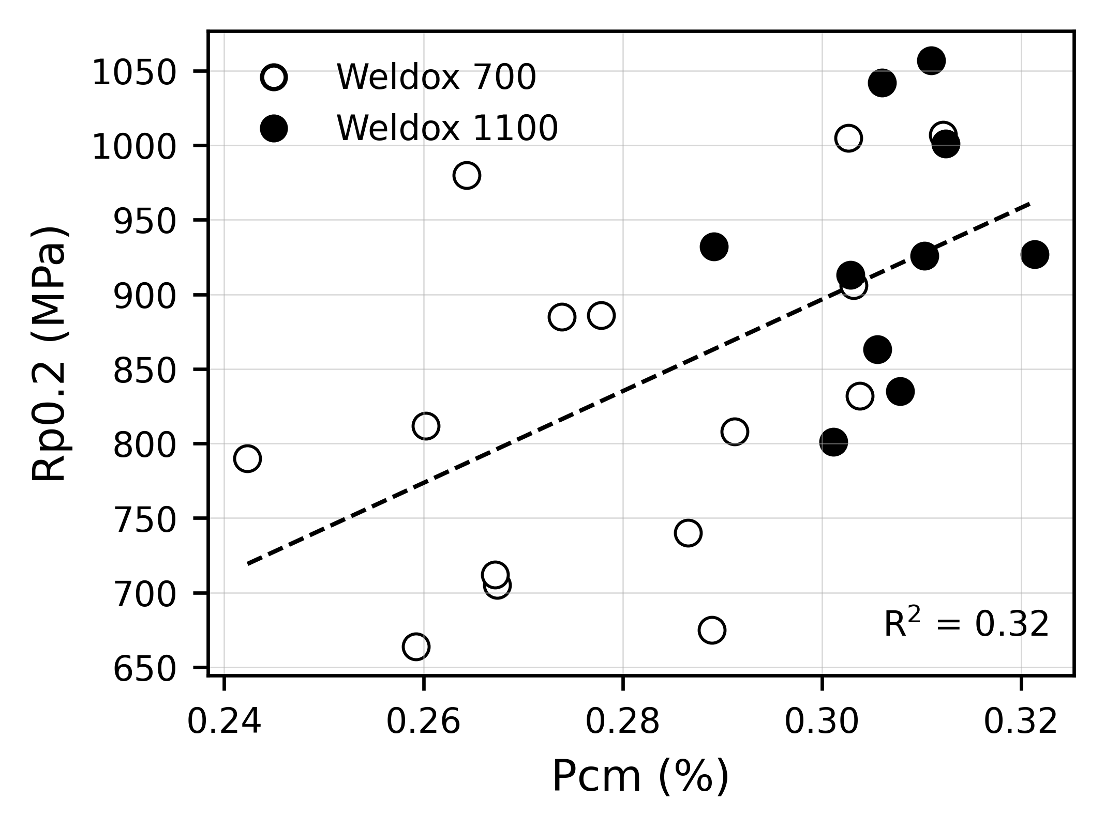
Figure 1. Weld metal yield strength, Rp0.2, plotted as a function of Pcm.

The corresponding relationship between tensile strength and Pcm is shown in Figure 2. Compared with yield strength, Rm follows the Pcm trend more clearly, which is also consistent with Svensson’s review of high-strength weld metals [5].
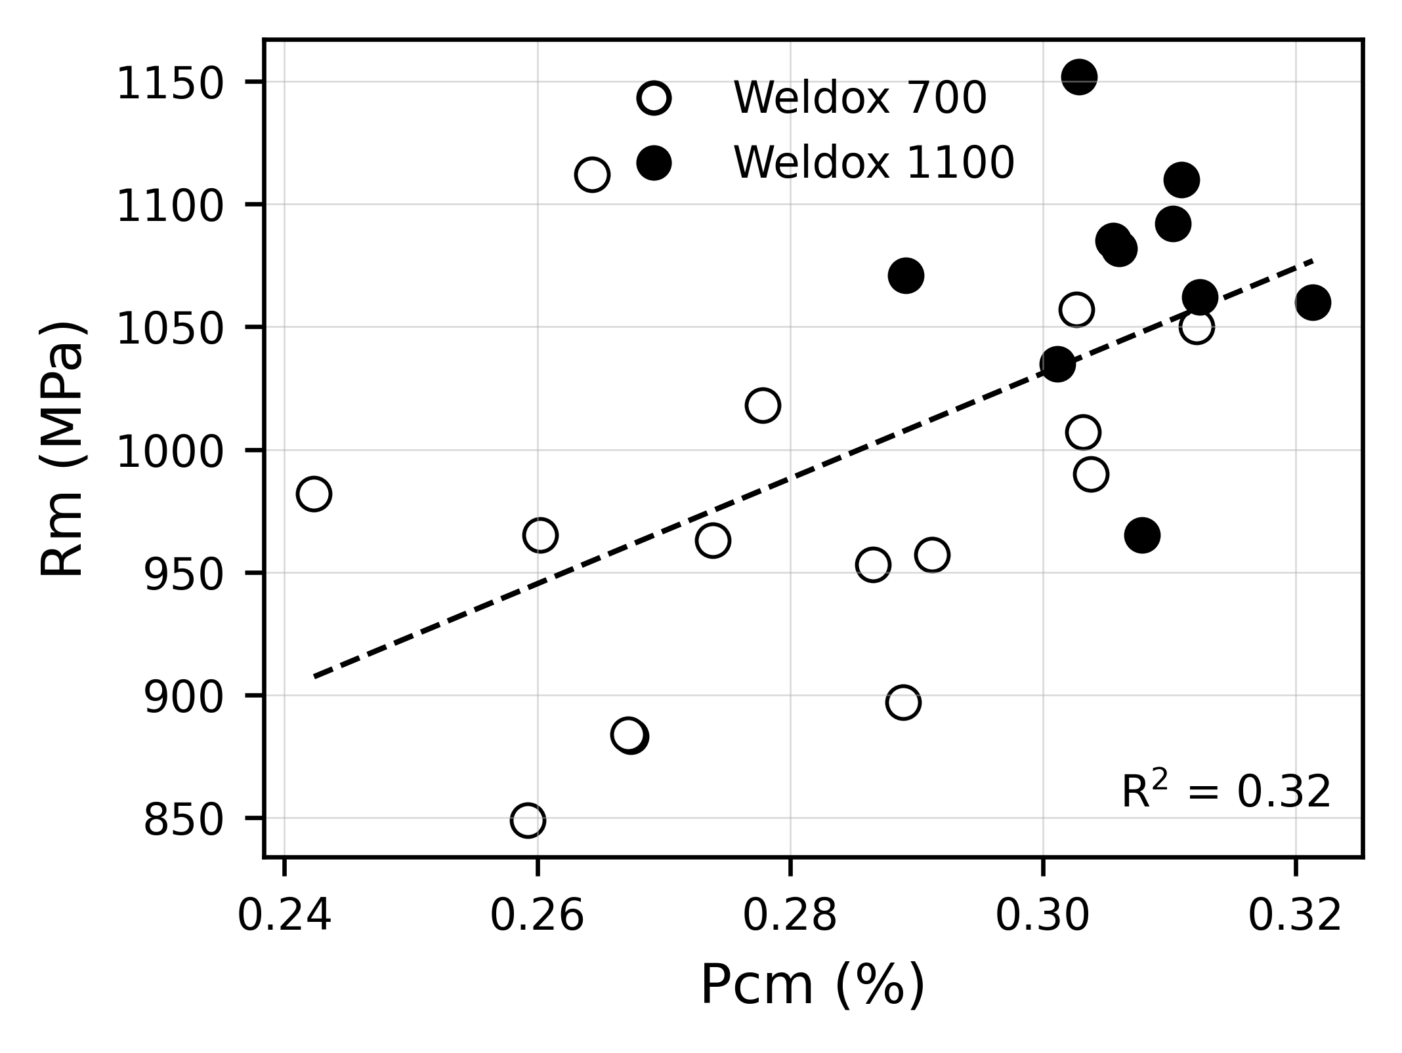
Figure 2. Weld metal tensile strength, Rm, plotted as a function of Pcm.

When Pcm was combined with t8/5, bead number and single-pass condition, the leave-one-out cross-validated R2 values were approximately 0.68 for Rp0.2 and 0.61 for Rm. Table 3 compares the carbon-equivalent descriptors.
Table 3. Comparison of carbon-equivalent descriptors for strength prediction.
Target | Best CE descriptor | Model variables | LOOCV R2 | LOOCV RMSE
Rp0.2 | Pcm | CE + t8/5 + bead number + single-pass | approx. 0.68 | approx. 64 MPa
Rm | Pcm | CE + t8/5 + bead number + single-pass | approx. 0.61 | approx. 49 MPa
Rp0.2 | CEn | CE + t8/5 + bead number + single-pass | approx. 0.65 | approx. 66 MPa
Rm | CEn | CE + t8/5 + bead number + single-pass | approx. 0.55 | approx. 53 MPa
Rp0.2 | CEIIW | CE + t8/5 + bead number + single-pass | approx. 0.62 | approx. 69 MPa
Rm | CEIIW | CE + t8/5 + bead number + single-pass | approx. 0.25 | approx. 68 MPa

CEIIW and CET were less effective, especially for tensile strength. This is reasonable because Pcm gives strong weight to elements relevant to hardenability in low-carbon high-strength weld metals, including C, Mn, Cr, Mo, V and B.

4.3 Compact strength model
A compact engineering model was developed using Pcm, t8/5, bead number, Ni-based dilution, single-pass condition and base-metal grade. This model was intended to use variables that are physically meaningful and relatively easy to interpret in welding procedure development.
The fitted equations were:
Rp0.2 = 247.7 + 1413.8(Pcm) + 1.32(t8/5) + 32.97(Nbeads) - 1.63(Dilution) + 305.8(SinglePass) + 60.4(Base1100)
Rm = 499.7 + 1425.5(Pcm) + 0.07(t8/5) + 12.24(Nbeads) - 0.81(Dilution) + 215.0(SinglePass) + 63.9(Base1100)
The performance of this model is given in Table 4.
Table 4. Performance of compact interpretable strength model.
Target | Training R2 | LOOCV R2 | LOOCV RMSE
Rp0.2 | 0.87 | 0.68 | 63 MPa
Rm | 0.84 | 0.66 | 46 MPa

The exact coefficients should not be interpreted as independent causal effects because process variables are coupled. For example, single-pass welding is linked to Rapid Arc and laser-hybrid conditions, while multipass welding is linked to reheating and tempering. However, the signs are metallurgically reasonable. Higher Pcm increases hardenability and strength. Increased dilution tends to reduce strength because the base steels are leaner than the consumables. Single-pass welding increases strength because the deposited weld metal is not tempered by subsequent passes [1,2].
This interpretation is also consistent with WAAM literature. Lin et al. showed that repeated thermal cycles in WAAM modify microstructure and hardness through tempering, recovery, recrystallisation and transformation effects [9]. Rafieazad et al. similarly showed that thermal cycling and deposition strategy can generate heterogeneous microstructures and anisotropic properties in WAAM steel blocks [10]. Although the present work concerns welding rather than WAAM, the same physical principle applies: thermal history and reheating strongly influence final microstructure and mechanical response.

4.4 Full-chemistry machine-learning models
When individual chemical elements were included together with process descriptors, strength prediction improved substantially. The overall model performance is compared in Figure 3 and summarised in Table 5.
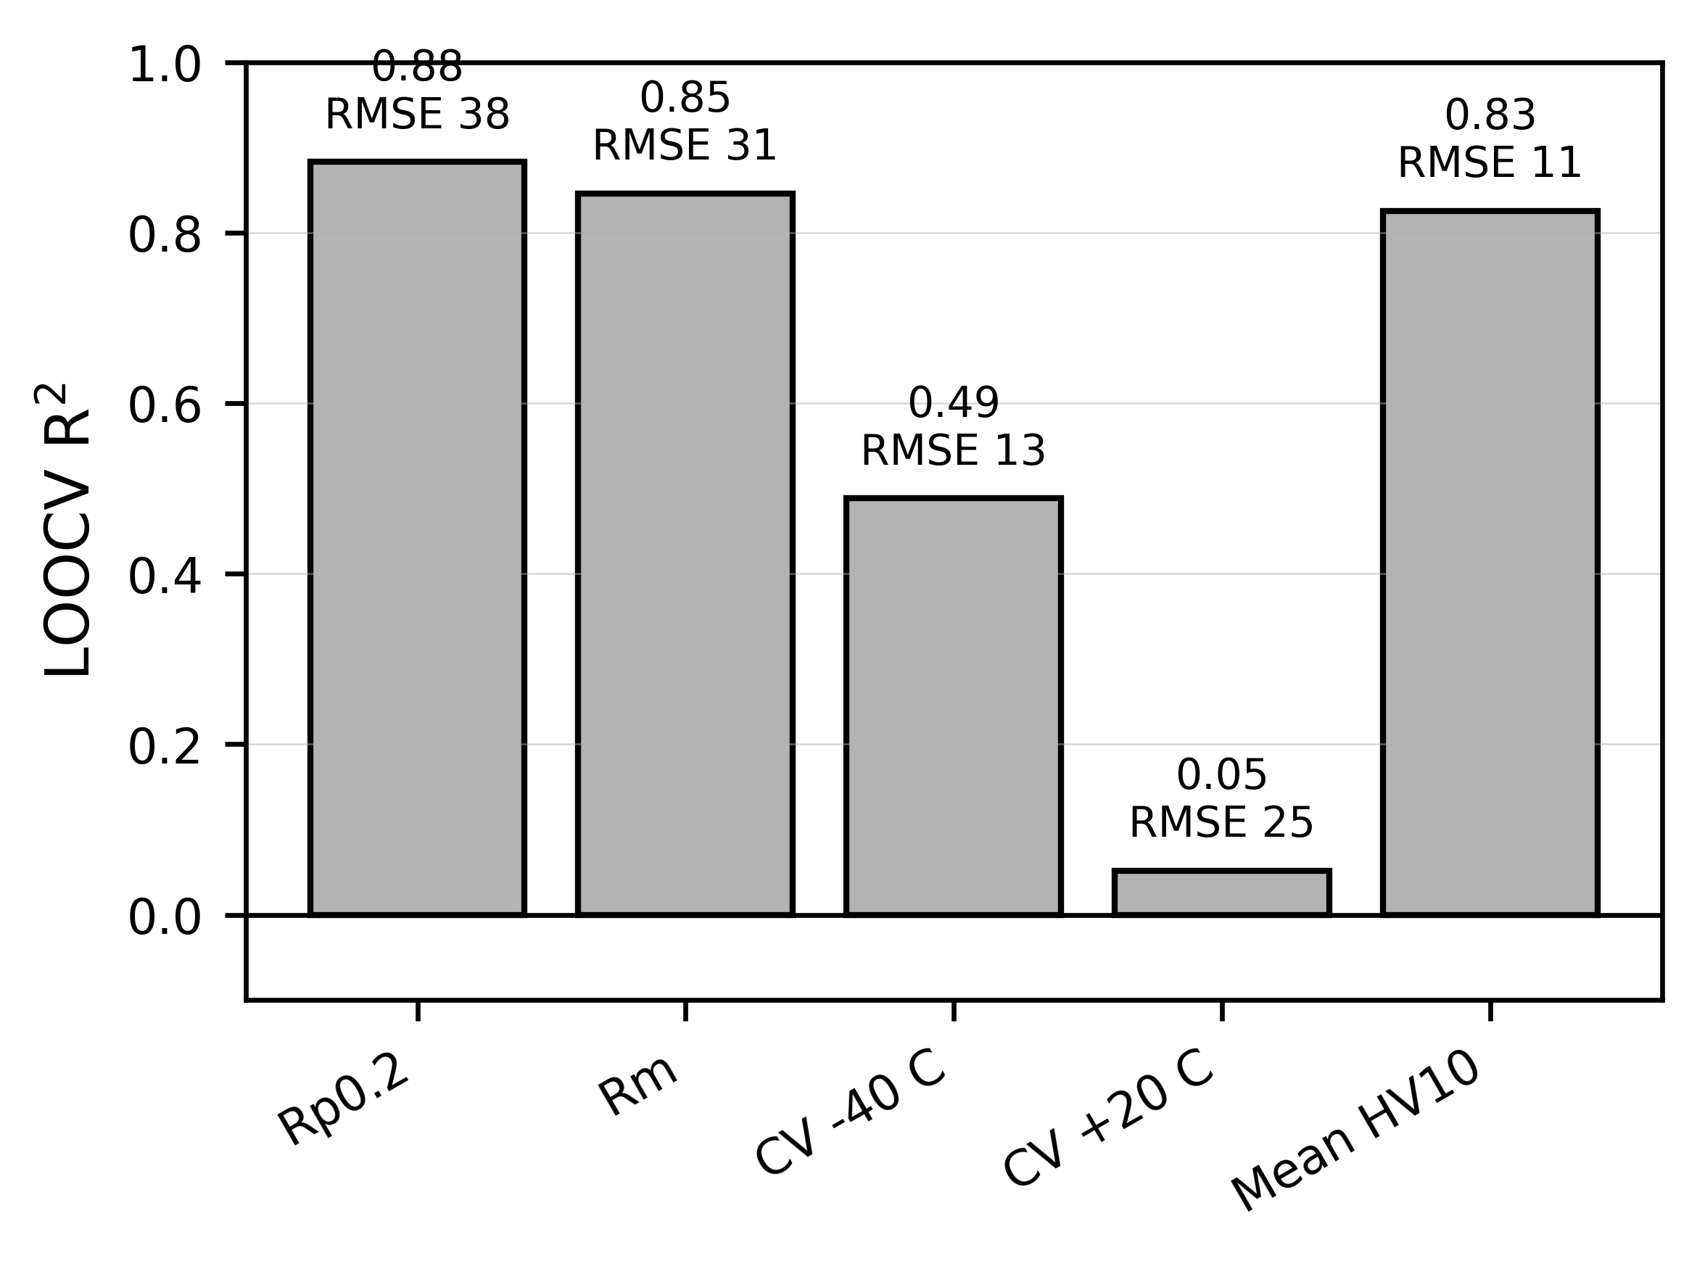
Figure 3. Cross-validated model performance for strength, toughness and hardness targets.

Table 5. Best-performing ML models for different target properties.
Target | Best model | Feature set | LOOCV R2 | LOOCV RMSE
Rp0.2 | Ridge regression | Full chemistry + process | 0.88 | 38 MPa
Rm | PLS regression | Full chemistry + process | 0.85 | 31 MPa
Charpy -40 C | Random forest | Full chemistry + process | 0.49 | 13 J
Charpy +20 C | Random forest | Full chemistry + process | 0.05 | 25 J
Mean HV10 | Random forest | Compact/process chemistry | 0.83 | 11 HV10

The improvement from the compact model to the full-chemistry model shows that Pcm is a useful simplification, but it does not capture all chemistry effects. Elements such as Ni, Mn, Mo, Cr and C do not only increase carbon equivalent; they also influence transformation path, prior austenite grain size, bainite/martensite balance and toughness response [5-8]. Therefore, full-chemistry models provide better prediction, while compact Pcm-based models provide clearer engineering interpretation.
The ridge-regression coefficient ranking for Rp0.2 is shown in Figure 4. This figure shows which variables contributed most strongly to the regularised strength model. The ranking supports the conclusion that strength is controlled by both composition and process history.
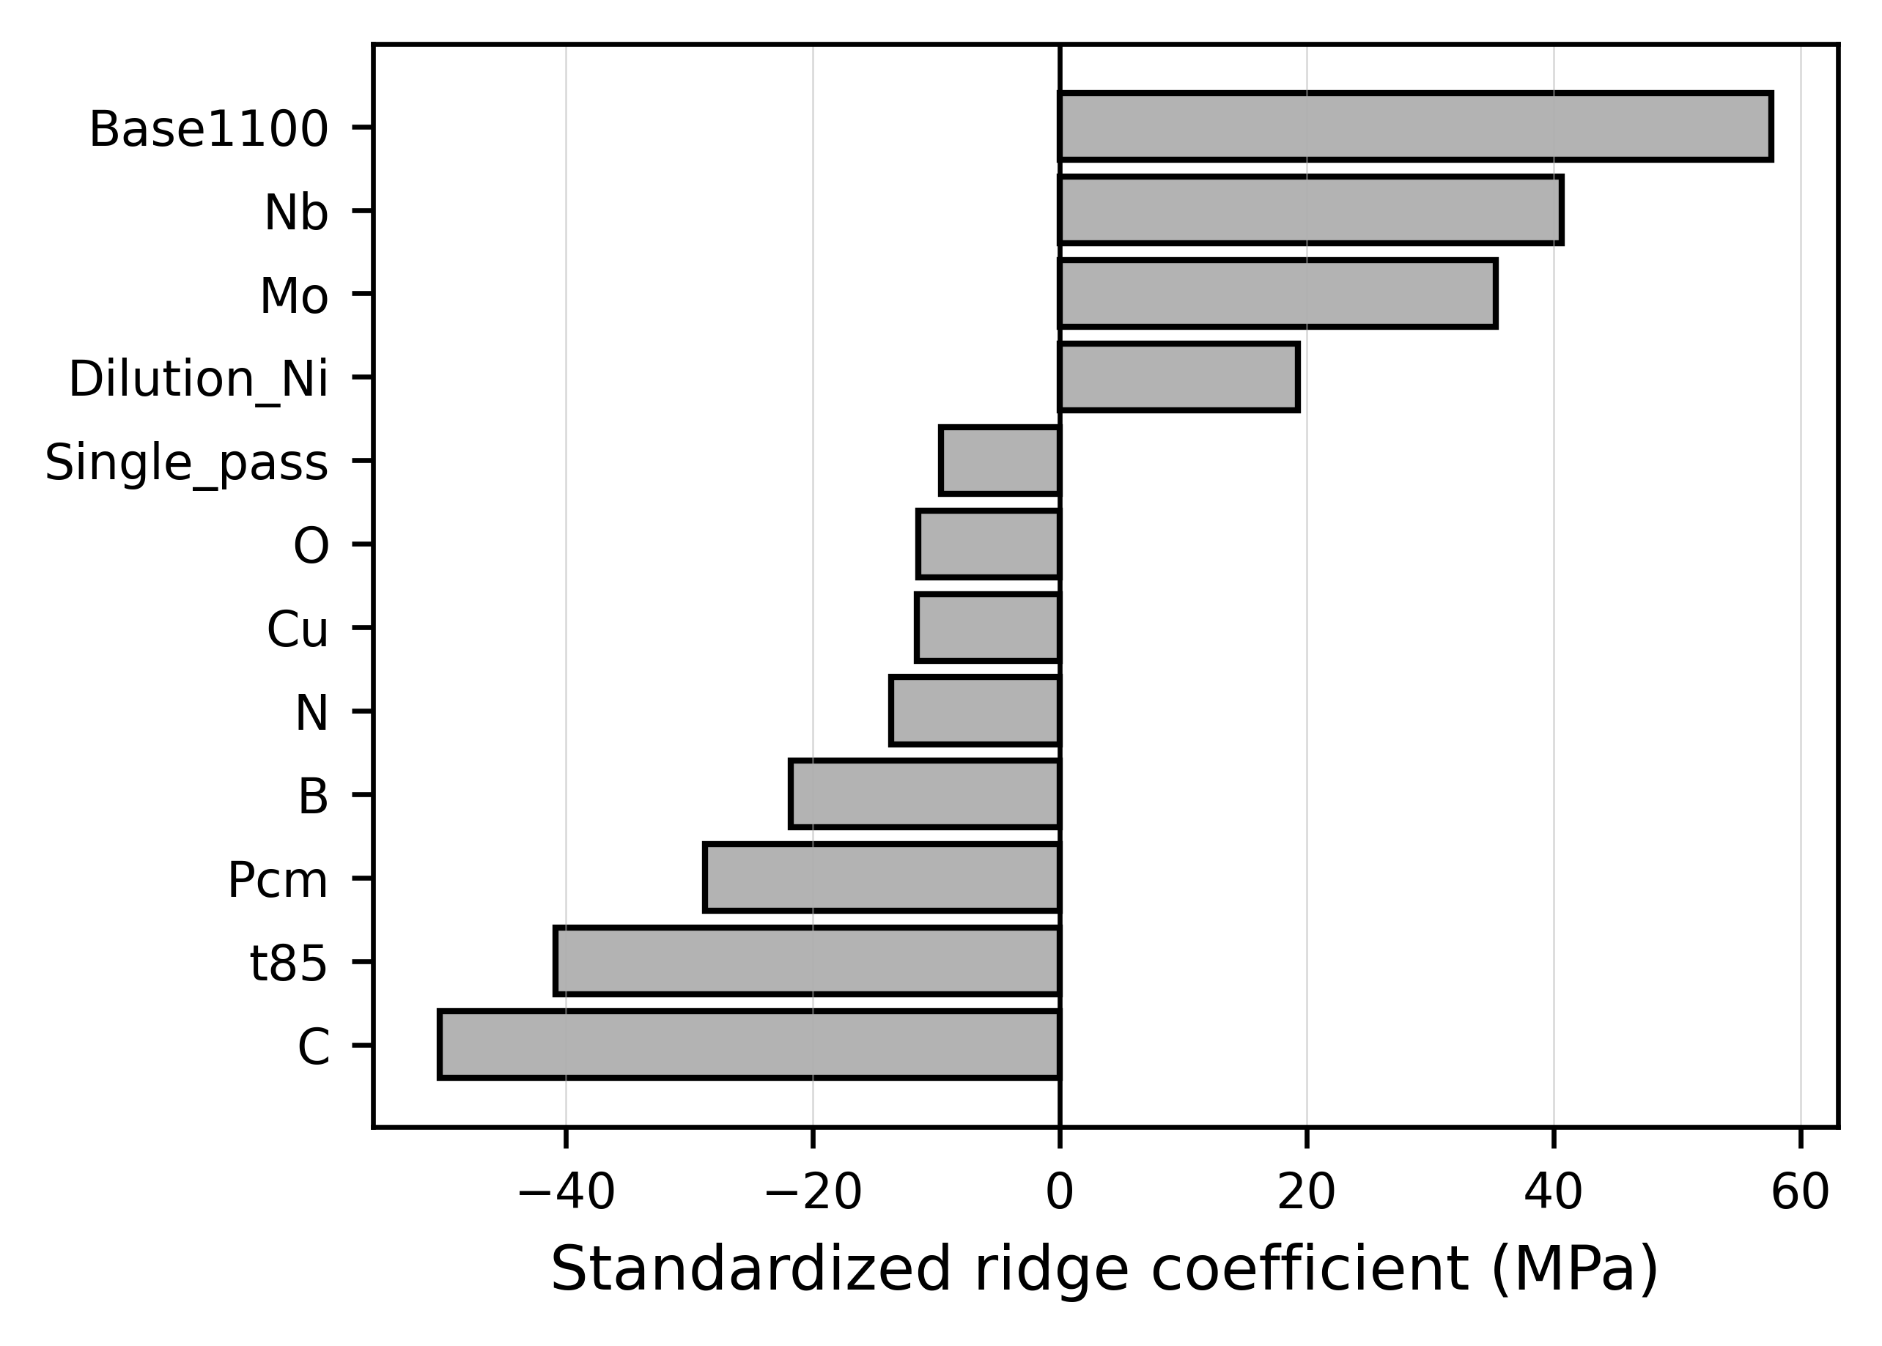
Figure 4. Ridge-regression coefficients for Rp0.2 prediction using chemistry and process features.

The most important practical message is that full chemistry improves strength prediction, but the compact model is still valuable because it uses variables that welding engineers can understand and control.

4.5 Dilution as a process-controlled chemistry variable
Dilution had a negative coefficient in the compact strength models. This supports the original interpretation that higher dilution generally reduces weld metal strength when a highly alloyed consumable is mixed with leaner base metal [1,2]. The direct relationship between Rp0.2 and Ni-based dilution is shown in Figure 5. The general trend is decreasing strength with increasing dilution, although scatter is significant.
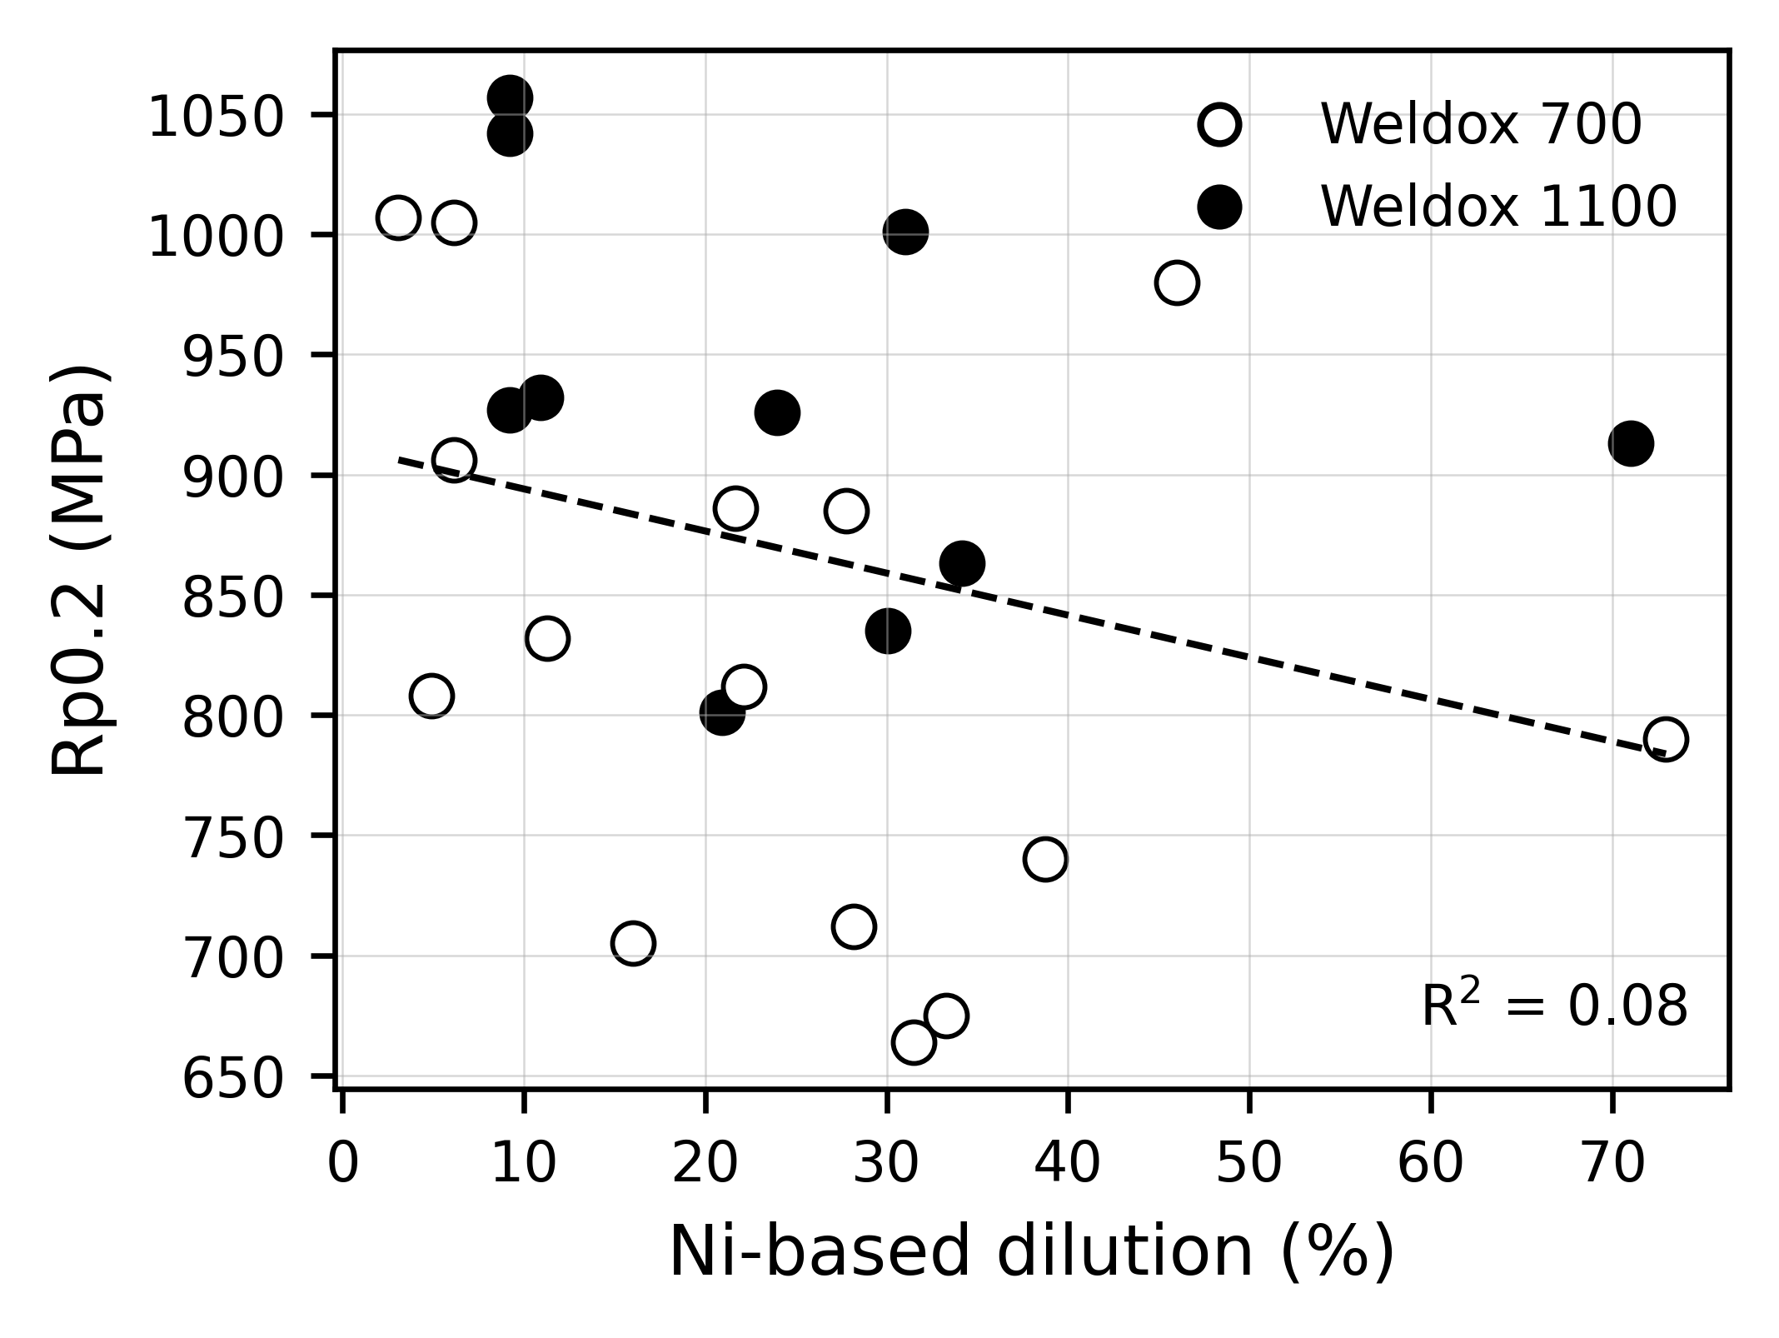
Figure 5. Weld metal yield strength, Rp0.2, plotted as a function of Ni-based dilution.

The scatter in Figure 5 is expected because dilution is coupled with welding method, bead number and thermal history. For example, laser-hybrid welds show high dilution but are also single-pass welds, while MMA welds show low dilution but are multipass welds. Therefore, dilution should not be interpreted only as a geometrical percentage.
Zhang et al. showed that dilution calculated from chemical composition can differ depending on the element selected, and that gross dilution in multi-element systems is more complex than a single geometrical value [11]. In the present dataset, Ni-based dilution was selected because Ni showed a large difference between base metal and filler and is relatively stable during welding [1]. This makes it useful, but still element-specific.
Therefore, dilution is best described as: Process -> Dilution -> Final weld chemistry -> Microstructure -> Properties.
This is one of the central interpretations of the paper. Dilution is not merely a geometrical weld-pool variable; it is a process-controlled chemical transformation that changes hardenability and therefore strength and toughness.

4.6 Strength-toughness relationship
Strength was much more predictable than Charpy toughness. Compact linear models gave reasonable cross-validated performance for Rp0.2 and Rm, but poor performance for Charpy toughness. The relationship between Charpy impact toughness at -40 C and tensile strength is shown in Figure 6. The general trend is decreasing toughness with increasing tensile strength.
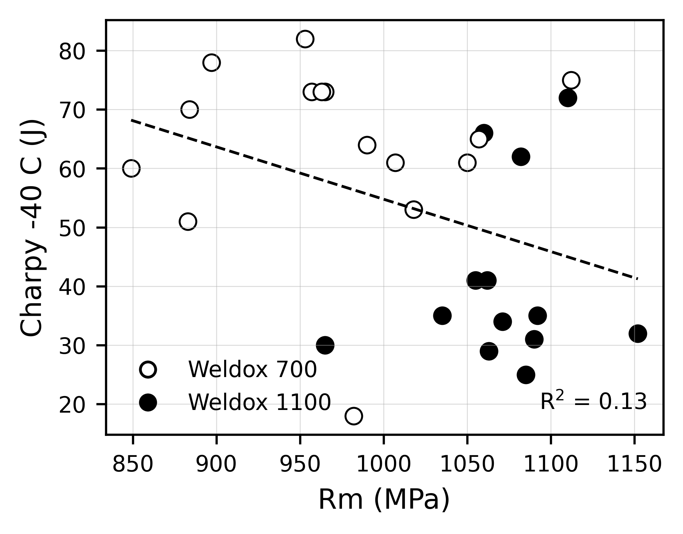
Figure 6. Charpy impact toughness at -40 C plotted as a function of tensile strength, Rm.

This behaviour is metallurgically meaningful. Toughness is controlled by more local features than strength. The original work noted that impact toughness depends on cleanliness, oxygen content, inclusion type, grain size and microstructural constituents [1]. Svensson also showed that Pcm can help rationalise strength, but toughness is highly dependent on the microstructure produced by a specific Mn-Ni alloying route [5]. For example, high strength can be obtained through martensite/bainite, but the toughness response depends on whether the structure is fine and well distributed or contains coarse/coalesced bainitic constituents [5].
The best Charpy -40 C model was a random forest model with moderate cross-validated R2 of about 0.49. The feature importance ranking from this model is shown in Figure 7. The ranking suggests that toughness is not controlled by a single dominant descriptor, but by several interacting chemistry and process variables.
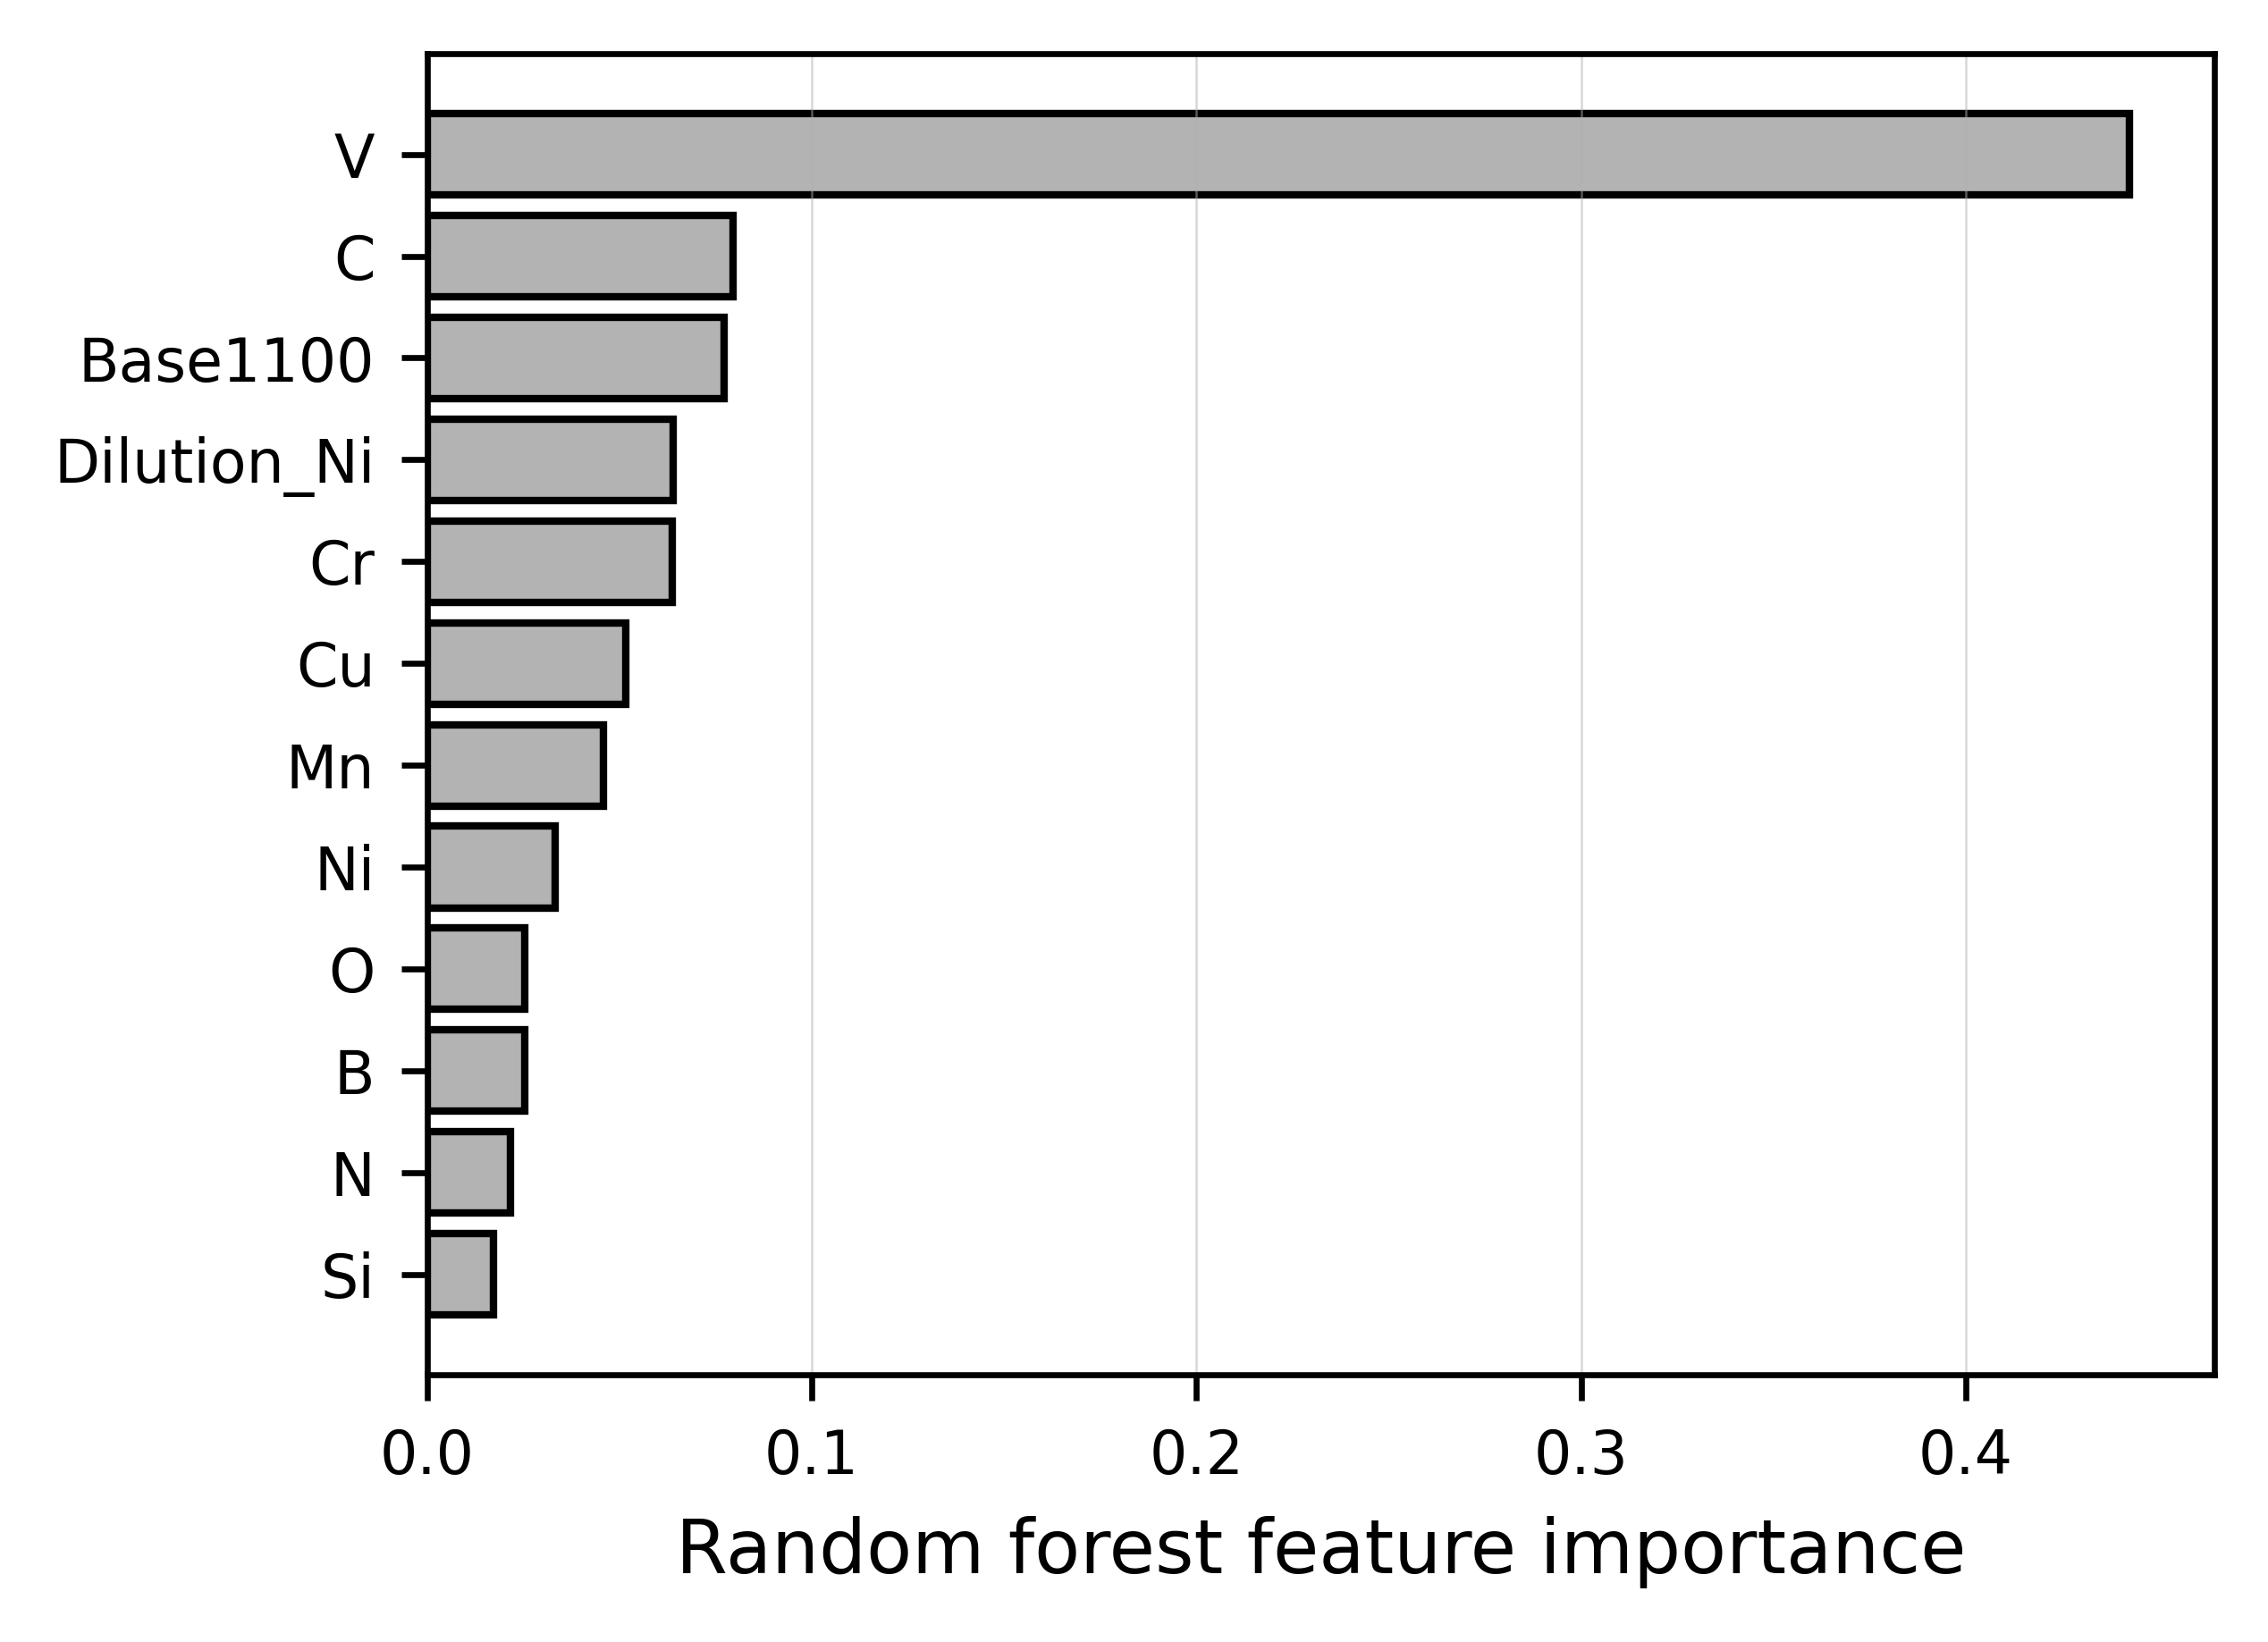
Figure 7. Random forest feature importance for Charpy -40 C prediction.

The present ML results therefore support the following conclusion: bulk chemistry and process variables are sufficient for approximate strength prediction, but not for robust toughness prediction. To improve toughness prediction, future datasets should include quantitative microstructure descriptors such as martensite/bainite fraction, acicular ferrite fraction, prior austenite grain size, packet/block size, inclusion density and inclusion size distribution.
This agrees with WAAM studies where mechanical anisotropy and toughness differences were attributed to local microstructural heterogeneity, interlayer discontinuities, inclusions and fracture-surface features [9,10].

4.7 Hardness and weldability
Hardness descriptors were more predictable than toughness. Mean HV10 was predicted with LOOCV R2 of approximately 0.83 and RMSE of about 11 HV10, as shown in Table 5. This suggests that hardness is strongly linked to chemistry and process history, and can serve as an intermediate property between microstructure and tensile strength.
The original work reported HAZ softening in both steels, especially in Weldox 1100 [1]. This is important because transverse tensile fractures in Weldox 1100 were often located in the HAZ or close to the fusion boundary [1]. For future modelling, the hardness profile should be segmented into weld metal, coarse-grained HAZ, softened HAZ and base metal. Such segmentation would make it possible to model local mismatch, HAZ softening and fracture location more directly.
Lin et al. showed in WAAM medium-carbon steel that hardness variations were controlled by phase constituents, grain size, precipitation, tempering and repeated thermal cycles [9]. Rafieazad et al. also showed that periodic microstructures and interlayer discontinuities reduced vertical mechanical performance in WAAM low-alloy steel [10]. These findings support the interpretation that local hardness descriptors are useful for capturing process-induced microstructural variation.

4.8 Limitations
The main limitation is the small dataset size. Although each data point is experimentally rich, 30 weld conditions are not enough for unrestricted machine learning. Therefore, the results should be viewed as interpretable small-data modelling rather than universal prediction.
The second limitation is variable coupling. Welding process, dilution, bead number, thermal cycle and reheating condition are not independent. Laser-hybrid welds are high-dilution and single-pass; MMA welds are low-dilution and multipass. Therefore, model coefficients should be interpreted together with metallurgy, not as isolated causal parameters.
The third limitation is the lack of quantitative microstructural descriptors. The dataset contains strong chemistry and mechanical information, but not enough numerical microstructural features to predict toughness robustly. Future work should add SEM/EBSD features, inclusion statistics and segmented hardness descriptors.

5. Conclusions
- A cleaned composition-process-property dataset was constructed from previous experiments on Weldox 700 and Weldox 1100 welds produced using MMA, GMAW/MAG, Rapid Arc, laser-hybrid welding and SAW.
- The new contribution is an interpretable statistical and machine-learning analysis of the existing experimental dataset, with emphasis on chemistry, dilution, cooling time, bead sequence and mechanical properties.
- Pcm was the best compact carbon-equivalent descriptor for weld metal strength. When combined with t8/5, bead number and single-pass condition, it predicted Rp0.2 and Rm with leave-one-out cross-validated R2 values of approximately 0.68 and 0.61, respectively.
- A compact engineering model using Pcm, t8/5, bead number, Ni-based dilution, single-pass condition and base-metal grade predicted Rp0.2 and Rm with RMSE values of approximately 63 MPa and 46 MPa.
- Full-chemistry models improved strength prediction. Ridge regression predicted Rp0.2 with LOOCV R2 = 0.88, while partial least squares regression predicted Rm with LOOCV R2 = 0.85.
- Charpy toughness was less predictable than strength. This indicates that bulk chemistry, dilution and t8/5 are insufficient for robust toughness prediction without quantitative microstructural and inclusion descriptors.
- Dilution should be treated as a process-controlled chemistry variable, not only as a geometrical mixing ratio. It changes final weld metal composition, hardenability and mechanical response.
- Hardness descriptors were relatively well predicted and should be developed further by segmenting weld metal, HAZ and base-metal regions.
- Interpretable small-data ML can support high-strength steel weld procedure development, but future work should integrate EBSD, SEM, inclusion analysis and local hardness-profile features to improve toughness and weldability prediction.

References
[1] L. Karlsson, L.-E. Svensson and K. Hurtig, “Influence of dilution on properties of high strength steel weld metals,” Biuletyn Instytutu Spawalnictwa, no. 5, pp. 62-71, 2014.
[2] L. Karlsson, L.-E. Svensson and K. Hurtig, “Efficient welding of high strength steel,” Swedish Production Symposium, Göteborg, Sweden, 2014.
[3] L. Karlsson, L.-E. Svensson and K. Hurtig, “Influence of dilution on properties of high strength steel weld metals,” 56th Welding Conference, Sosnowiec, Poland, 2014.
[4] F. Sikström, K. Hurtig and L.-E. Svensson, “Heat input and temperatures in welding,” Proceedings of JOM 17, International Conference on Joining Materials, Helsingør, Denmark, 2013.
[5] L.-E. Svensson, “Microstructure and properties of high strength weld metals,” Materials Science Forum, vol. 539-543, pp. 3937-3942, 2007.
[6] Z. Zhang and R. A. Farrar, “Influence of Mn and Ni on the microstructure and toughness of C-Mn-Ni weld metals,” Welding Journal, vol. 76, no. 5, pp. 183s-196s, 1997.
[7] B. Y. Kang, H. J. Kim and S. K. Hwang, “Effect of Mn and Ni on the variation of the microstructure and mechanical properties of low carbon weld metals,” ISIJ International, vol. 40, pp. 1237-1245, 2000.
[8] E. Keehan, L. Karlsson, H.-O. Andrén and H. K. D. H. Bhadeshia, “Influence of C, Mn and Ni on strong steel weld metals: Part 1-3,” Science and Technology of Welding and Joining, vol. 11, pp. 1-24, 2006.
[9] Z. Lin, C. Goulas, W. Ya and M. J. M. Hermans, “Microstructure and mechanical properties of medium carbon steel deposits obtained via wire and arc additive manufacturing using metal-cored wire,” Metals, vol. 9, article 673, 2019.
[10] M. Rafieazad, A. V. Nemani, M. Ghaffari and A. Nasiri, “On microstructure and mechanical properties of a low-carbon low-alloy steel block fabricated by wire arc additive manufacturing,” Journal of Materials Engineering and Performance, vol. 30, pp. 4937-4945, 2021.
[11] Z. Zhang, X. Huang, P. Yao and J. Xue, “A new method for weld dilution calculation through chemical composition analysis,” Metals, vol. 11, article 131, 2021.
[12] S. W. Williams, F. Martina, A. C. Addison, J. Ding, G. Pardal and P. Colegrove, “Wire + arc additive manufacturing,” Journal of Materials Science & Technology, vol. 32, pp. 641-647, 2016.
[13] T. A. Rodrigues, V. Duarte, R. M. Miranda, T. G. Santos and J. P. Oliveira, “Current status and perspectives on wire and arc additive manufacturing,” Materials, vol. 12, article 1121, 2019.
[14] W. E. Frazier, “Metal additive manufacturing: A review,” Journal of Materials Engineering and Performance, vol. 23, pp. 1917-1928, 2014.
[15] L. Karlsson and H. K. D. H. Bhadeshia, “Some European developments in welding consumables,” Journal of the Japan Welding Society, vol. 80, no. 1, pp. 110-119, 2011.
[16] F. Pedregosa et al., “Scikit-learn: Machine learning in Python,” Journal of Machine Learning Research, vol. 12, pp. 2825-2830, 2011.
[17] L. Breiman, “Random forests,” Machine Learning, vol. 45, pp. 5-32, 2001.
[18] R. Tibshirani, “Regression shrinkage and selection via the lasso,” Journal of the Royal Statistical Society: Series B, vol. 58, pp. 267-288, 1996.

